TITLE OF PAPER
(Title: Upper case, Bold, Times New Roman, Font Size 16, Centred;
Page margin of top, bottom, left, and right = 2.54 cm)

ALI AHMAD^{1*}; JOHN VIRK² and XING TAN³
(Uppercase, Bold, Times New Roman, Font Size 12, Centred, Superscript 1, 2, 3, etc. to Indicate Affiliation, Superscript * to Indicate Corresponding Author)

¹ Malaysian Palm Oil Board, 6, Persiaran Institusi, Bandar Baru Bangi, 43000 Kajang, Selangor,
Malaysia.
² Faculty of Science and Technology, Universiti Kebangsaan Malaysia, 43600 UKM Bangi,
Selangor, Malaysia.
³ Malaysian Timber Industry Board, 42700, Banting, Selangor, Malaysia.

(Indicate authors’ affiliation with superscript 1, 2, 3, etc., and start each address on a new line, Times New Roman, font size 12)

*Corresponding author e-mail: aliahmad@mpob.gov.my [Times New Roman, italic, font size 12]

ABSTRACT
An abstract is required for every paper. Your abstract should give readers a brief summary of your article. It should concisely describe the contents of your article and include key terms. It should be informative, accessible, and not only indicate the general scope of the article but also state the main results obtained and conclusions drawn. The abstract should be complete in itself; it should not contain undefined abbreviations, and no table numbers, figure numbers, references or equations should be referred to. It should be suitable for direct inclusion in abstracting services and should be within 150-200 words.

Keywords: anaerobic-aerobic, biogas, biological oxygen demand, palm oil.
(3-5 words; lower case, Times New Roman; font size 12; arrange alphabetically)

Received: (JOPR use only); Accepted: (JOPR use only); Published online: (JOPR use only)

INTRODUCTION
[All first-order headings (Header) use Times New Roman, font size 12, bold, and centred]
The paper must be in UK/US English. Naturally, your paper should start with a concise and informative sentence describing the title of the article. Do not use abbreviations in it. Next, list all authors with their first names or initials and surnames (in that order). Indicate the author for correspondence. After having listed all authors’ names, you should list their respective affiliations. Link authors and affiliations using superscript lower-case letters. In general, the contents should comprise Introduction, Materials and Methods, Results and Discussion, Conclusion, Acknowledgement, and References. The manuscript should be supplied with 3-5 keywords.
Authors are expected to consider the list and order of authors before submitting their manuscript and provide the definitive list of authors at the time of the original submission. Any addition, deletion, or rearrangement of author names in the authorship list should be made only before the manuscript has been accepted and only if approved by the journal Editor. To request such a change, the Editor must receive the following from the corresponding author: (a) the reason for the change in the author list and (b) written confirmation (e-mail, letter) from all authors that they agree with the addition, removal, or rearrangement. In cases of author addition or removal, this includes confirmation from the author. No additions, deletions, or changes to the authorship of a paper will be permitted after the article is accepted.

MATERIALS AND METHODS
You will usually want to divide your article into first-order headings and second-order headings (perhaps even third-order headings). Headings should reflect the relative importance of the sections. Methods should be described in the past tense, as you are describing work that was carried out to achieve the objective of the study.

Journal of Oil Palm Research [Second order headings (subheader) should be bold, Times New Roman, font size 12, capitalised each first word.]
Journal of Oil Palm Research (JOPR) is an international refereed journal on various aspects of oil palm and/or palm oil. The journal is circulated extensively within Malaysia as well as other countries to individuals, commercial organisations, agencies related to oil palm and palm oil, abstracting companies, and academic institutions. JOPR covers the study and exploitation of areas such as Biology & Sustainability, Food technology, Oleochemistry, Breeding, and Engineering. Authors should clearly define their category of work in the cover letter. The journal publishes research articles, reviews, and short communication whose content and approach are of interest to a wide range of scholars.
In order to maintain the high standards associated with JOPR, papers submitted are thoroughly scrutinised on their quality, especially in their originality, context, and universality of the findings. Of course, they have to be readable in Standard English. Every paper published should preferably be at the cutting edge of science or share something new and exciting.

[Third order headings (sub-subheading) should be bold, italic, Times New Roman, font size 12, capitalised the first word]
Regular article. Full-length original empirical investigations, consisting of introduction, materials and methods, results and discussion, and conclusion. Original work must provide references and an explanation of research findings that contain new and significant findings. The conclusion should be brief and focus on the research output, should not be in point form. These papers should not exceed 6,000 words of text (including tables, figures, and references) and generally not more than a total of 10 figures and tables. After peer-review, the article's word count limit can be extended to a maximum of 8,000 words to better address the reviewers’ and editors’ comments. Any additional figures or tables can be included in the supplementary data. Please note that papers submitted to JOPR will be sent back to authors because of poor figure resolution or exceeding the number of figures permitted.

Short communication. Significant new information to readers of the Journal in a short but complete form. Preferably not exceeding 3,000 words (including tables, figures, and references), and is intended for rapid publication. They are not intended for publishing preliminary results or to be a reduced version of Regular papers.

Review article. Critical evaluation of materials about current research that have already been published by organising, integrating, and evaluating previously published materials. Re-analyses as meta-analyses and systematic reviews are encouraged. Review articles provide systemic overview, evaluation, and interpretation of research in a given field. They should not exceed 12,000 words (including references) and should contain no more than a total of 20 figures and tables. Any additional figures or tables can be included in the supplementary data. Please note that papers submitted to JOPR will be sent back to authors because of poor figure resolution or exceeding the number of figures permitted. The same information should not be repeated in a figure and a table.

RESULTS AND DISCUSSION
All illustrations must be labelled and supplied after being introduced in the text. The illustrations of photographs, schemas, graphs, and diagrams are to be referred to as figures. A figure is to demonstrate a trend or lead to a conclusive statement, and is a raw spectrum or chromatography that should be accepted in a scientific article. Figures should be placed at the top or bottom of a page wherever possible, as close as possible to the first reference to them in the paper. These illustrations should be referred to and numbered serially, as figures (Figure 1). All Tables and Figures cited in the text must be in italics e.g. Figure 1. The figure number and caption should be typed below the illustration in Times New Roman, font size 12, italic, and centred as shown in Figure 1 and 2.

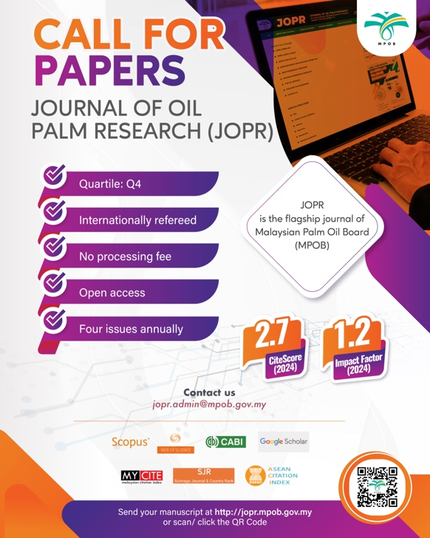

Figure 1. Illustration text and caption should be Times New Roman,
font size 12, italic, centered, and included in body text.

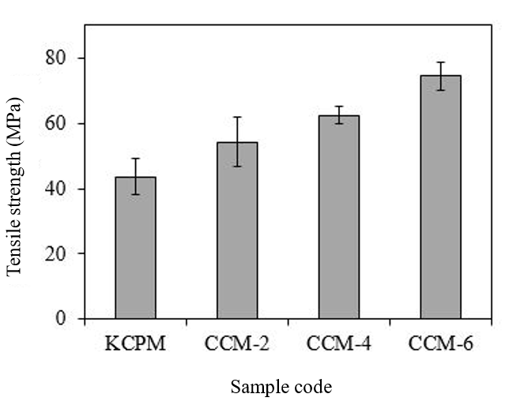

Figure 2. All the text and numbers in the illustrations must be in Times New Roman
and font size 12. Lettering and symbols should be clearly defined in the caption.

Keep text in the illustrations themselves to a minimum, but explain all symbols and abbreviations used. All the text and numbers in the illustrations must be in Times New Roman and font size 10. Please indicate the Y & X-axis as well as the unit of measurement. Lettering and symbols should be clearly defined in the caption. Please ensure that all the figures are at least 500 dpi resolution, as this will facilitate good output. All illustrations should be clearly drawn in permanent ink or photographed in sharp black and white and reproduced in the form of high contrast glossy prints or digital images and provided in camera-ready form.
All tables must be labelled and supplied after being introduced in the text. Tables should be placed at the top or bottom of a page wherever possible, as close as possible to the first reference to them in the paper. These tables should be referred to and numbered serially, as tables (Table 1). Every table should have a caption, and headings should be placed above tables. The table number and caption should be typed in uppercase, Times New Roman, font size 12, bold, and centred.

TABLE 1. UPPERCASE, TIMES NEW ROMAN,
FONT SIZE 12, BOLD AND CENTERED
Type | Title two | Title three | Title four | Title five | Title six
A | 12 | 16 | 11 | 11 | 10
B | 1 | 4 | 7 | 6 | 2
C | 15 | 5 | 9 | 4 | 17

Note: FFA - free fatty acid; SA- stearic acid.

Source: World (2020)

All the text and numbers in the tables must be in Times New Roman, font size 10, and centred. In the table heading, no initial capitals except for the first word. Lettering and symbols should be clearly defined either in the caption of the table. Only horizontal lines should be used within a table to distinguish the column headings from the body of the table, and immediately above and below the table. Table 1 is an example that the authors may find useful. Please ensure that the data presented in figures or tables do not duplicate results described elsewhere in the article.

CONCLUSION
Manuscripts should be submitted via: https://www.editorialmanager.com/jopres/default.aspx. It is the author’s responsibility to ensure that his or her submitted work does not infringe any existing copyright. Authors should obtain permission to reproduce or adapt copyrighted material and provide evidence of approval upon submitting the final version of a manuscript. Manuscripts will be reviewed by the Editorial Board and at least one independent referee. Decisions regarding the publication of a manuscript will be based on the Board’s recommendations. The manuscript will be evaluated based on its appropriateness for JOPR, contribution to the discipline, cogency of analysis, conceptual breadth, clarity of presentation, and technical adequacy. Manuscripts submitted by members of the journal’s Editorial Board are subjected to the same review procedure.

ACKNOWLEDGEMENT
The information presented in the acknowledgment section should be kept brief, identify the contributors responsible for specific parts of the project. It should only mention people directly involved with the project from a sponsoring institution, other researchers who have helped in the preparation. This template gives formatting guidelines for authors preparing papers for publication in the JOPR. The authors must follow the instructions given in the document for the papers to be published.

REFERENCES

References in the text should be denoted by giving the name(s) of the author(s). All alphabetically ordered references should be included at the end of the manuscript. All references cited in the text must appear in the reference list and vice versa. In the JOPR manuscript, narrative citations such as Aliza et al. (2020), Adam and Idris (2016), and Malaysian Timber Board (MTB, 2025) are preferred. However, most authors currently use parenthetical citations, e.g., (Faizah et al., 2020; Khairul & Nazmie, 2021; Malaysian Palm Oil Board [MPOB], 2016). Authors are responsible for the accuracy and completeness of all information in the reference. Manuscripts must conform to the references in APA Style 7th edition (https://apastyle.apa.org/style-grammar-guidelines/references/examples). The reference style adopted should be consistent throughout the manuscript.

